[DCO-2418] All Channels - Authenticated Signers Password must be actioned using keyboard Created: 30/Apr/24 Updated: 06/May/24
Status: | In External Review
Project: | Journey Manager
Components: | None
Affects versions: | None
Fix versions: | Accessibility

Type: | Story | Priority: | None
Reporter: | Sanya Khandhuja | Assignee: | Fusi Olateru
Resolution: | Unresolved | Votes: | 0
Labels: | Business-self-serve, Motive, MotiveAuthenticated, Personal-self-serve
Remaining Estimate: | Not Specified
Time Spent: | Not Specified
Original estimate: | Not Specified

Attachments: | image-20240430-132808.png
QA Bug Count: | 0
Days Open: | 6 days
Bug Count: | 0
Hours Variance: | 0
Hours Remaining: | 0
Hours Target PMO: | 0
Sprint:
Days Open: | 6

Description

When logging into existing accounts, the password field contains a show password
control that cannot be actioned using a keyboard only. The control fails to gain keyboard
focus (due to <span> elements not getting native keyboard focus).
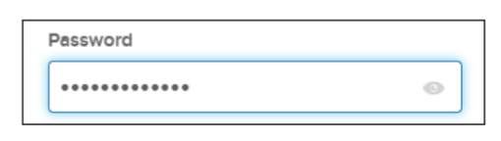
■ Recommendation: Ensure that all controls can be actioned using a keyboard only.

Comments

Comment by Fusi Olateru [ 03/May/24 ]
probably cannot change this too.
Generated at Mon May 06 21:46:17 UTC 2024 by Ian Hicks using Jira 1001.0.0-SNAPSHOT#100252-rev:aa264b414382dcd2bbea0c3e63c78e358e7de0d5.

